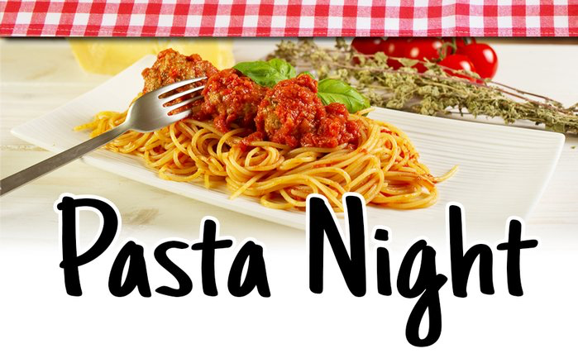
Carry Out or Dine-in
Monday & Tuesday
$12.99
Choice of pasta:
Spaghetti, Penne, Angel hair, Farfalle.
Choice of sauce:
Basil pesto, Carbonara, Marinara orAlfredo.
Add Chicken, Sausage or Meatballs for only $2.00

